Be Warned, God will always have a King over you
Psalm 2, 2 Samuel 7
7 January 2018

Introduction: Vain Rebellion

Why is Our Rebellion Vain?

God’s Heavenly Rule

God’s Plans to Rule Through His King

The OT looks Forward to this King
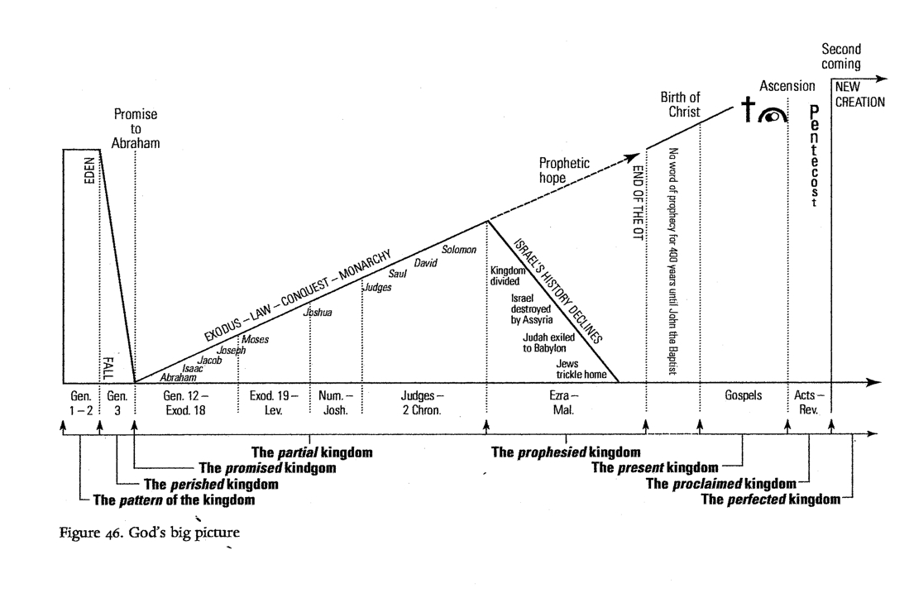

Jesus is the Ultimate Fulfillment of this King

Jesus the True Son

God’s wrath revealed in the Son

Be Wise…Kiss the Son

Application

